|  |  |
| --- | --- |
|  | Foundation Activity 9 Servo Motors |

Servo Motors

|  |  |
| --- | --- |
| Servo motors can be instructed to turn to a specific angle, usually from 0 to 180 degrees. | [1] |

We can use an Arduino microcontroller to send a control signal to the servo motor.

|  |  |  |
| --- | --- | --- |
|  |  |  |

Controlling a Servo Motor with an Arduino Microcontroller

Your goal is to make the motor: 1) move from 0 to 90 degrees 2) wait one second 3) rotate back to 0 degrees 4) wait another second, then repeat.

Using BlocklyDuino, you will need two functions (blocks), one to tell the servo what angle to turn to, and another to wait so the servo motor time to move.

|  |  |
| --- | --- |
| **Servo – Degree Function**  Click “**Servo**” from the left side-bar menu. Select the top block. Set the two arguments:   1. **PIN#**: The output pin that is connected to the “Signal” wire of the motor 2. **Degree**: The degree we want the motor to turn to. |  |
| **Delay Function**  Click “**Control**” from the left side-bar menu. Select the Delay block. The one argument is how many milliseconds the Arduino should delay. |  |

Programming an Arduino Microcontroller

1. Open BlocklyDuino program and the Arduino IDE program.
2. Write instructions for the Arduino microcontroller using blocks in BlocklyDuino.
3. Click the “**Arduino**” tab in BlocklyDuino, select the code, and copy it
4. Go to the Arduino IDE and delete any code already there.
5. Paste the code into the Arduino IDE.
6. Make sure the Arduino is connected to the computer using a USB cable
7. Click “**Tools**” on the top menu bar in the Arduino IDE, and make sure that “**Arduino UNO**” is selected under “**Board**”.
8. Click “**Tools**” on the top menu bar in the Arduino IDE, go to “**Port**”, and select the port that appears there after the Arduino is connected.
9. Click the arrow button  to upload the program to the Arduino

Connecting the Arduino Microcontroller to the Servo Motor

Here, the Arduino UNO controls the Servo Motor using output pin 8; **any** other output pin could also be used, as long as you specify the correct pin in the **Servo – Degree Function** in our instructions.

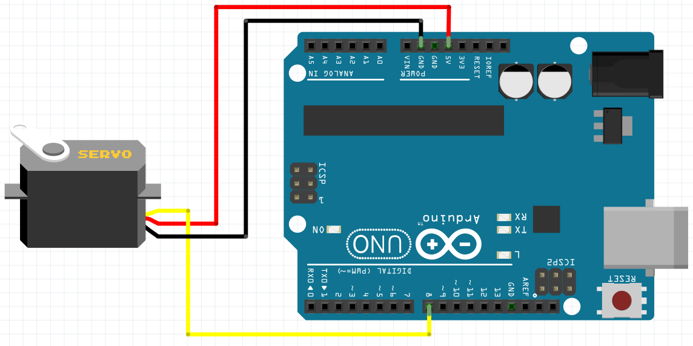

1. Servo and Arduino images from Fritzing.